Lab 13: Motion
Name: Farooq Ahmodu
PSY 2001

Objective:
To perform a random walk and determine how the result can be used to predict what will happen on the average
Procedure:
Requirements:
- A coin to flip
- Open space
Tried This:
Got out to a large open field and marked a spot on the ground. Took with me a coin like a nickel or a quarter. Stood on the spot and flipped the coin. The coin came up heads, I turned to the right and took a large step. The coin came up tails, I turned to the left and took a large step. Kept doing this many times to see where I would end up.
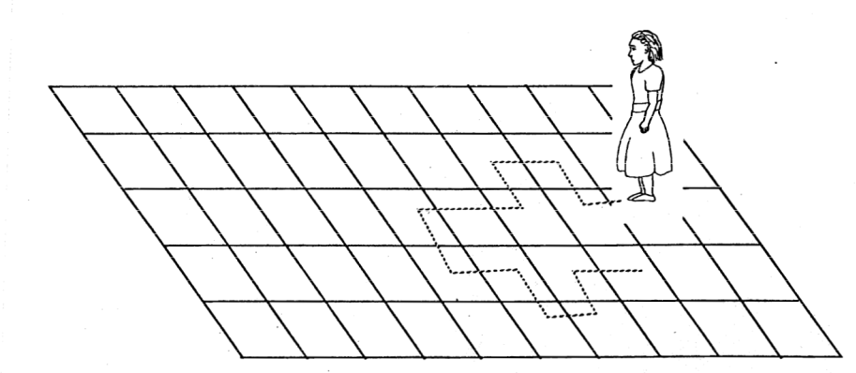

Theory:
Taking a Random Walk
Things in nature often move in complicated ways. You have probably watched the way a butterfly moves. The molecules of the air that you are breathing move in a similar way. This type of motion we call a random walk. I took a random walk
Experimental Results:
On flipping the coin 25 times I was five steps away from where I started. This is because five times five equals 25.
On flipping the coin 4 times I was 2 steps away from where I started
On flipping the coin 16 times I was 4 steps away from where I started

Calculations and Error Analysis:
R = √ N .
Where R = steps away from where I started
N = Number of times the coin is flipped
Hence for 4 flips R = $√4$ = 2 steps
16 flips, R = $\sqrt{16}$ = 4 steps
How far would you expect to be if you flipped the coin 100 times?
100flips, R = $\sqrt{100}$ = 10steps
Conclusion:
On trying this random walk, I noticed that sometimes I would go much farther than expected and sometimes ended up very close to where i started. But on trying it repeatedly, the average distance came as expected i.e. R = √ N .
Where R = steps away from where I started
N = Number of times the coin is flipped
What can be concluded from this activity is that we can often predict what will happen on the average even when the process is random.

